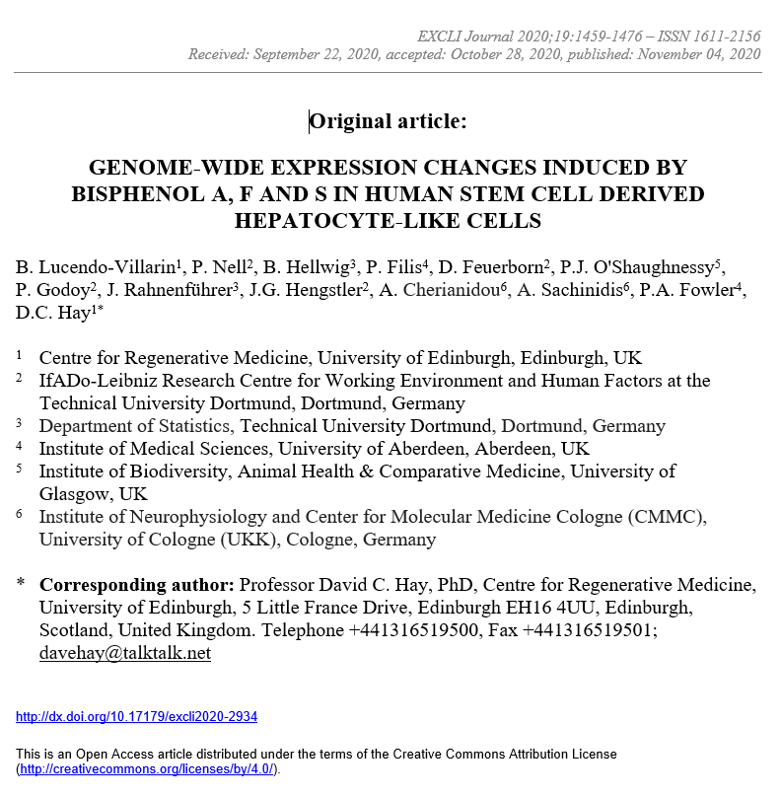

Supplementary Table 11: Antibodies employed in immunofluorescence studies
Antigen | Manufacturer | Host | Dilution
HNF4α | Santa Cruz | Rabbit | 1:100
Albumin | Abcam | Mouse | 1:100
Alpha-fetoprotein | Abcam | Mouse | 1:500
IgG | DAKO | Rabbit | 1:400
IgG | DAKO | Mouse | 1:400
Alexa Fluor 568 anti rabbit | Life Technologies | Donkey | 1:400
Alexa Fluor 488 anti mouse | Life Technologies | Goat | 1:400

